Dear All,

It is time for a report. My wife and I visited the Netherlands and we attended the Commemoration of the “End of WWll” in The Hague with some 2000 others, many of whom were 2nd and 3rd generation. The actual number of survivors present reduces every year. It was very impressive.
King Willem-Alexander was also present and laid the first wreath at the Indisch Monument. Next to the microphone stand was a Dutch flag (see photo in this newsletter). The original flag was taken apart, hidden and reassembled after 3 ½ yrs in Camp Ambarawa. The speeches of actor Eric Schneider and scholar Sanne were very emotional. A fly-over of a Catalina aircraft was emotional for many of the visiters. On the TV report my wife and I were seen as I laid flowers for EJOS and my parents at the beautiful Indisch Monument. After the ceremony, a bus took visitors to the Zuiderzee Theatre where we enjoyed an Indonesian Lunch.
There was tension and an expectant looking forward to the Prime Minister Mark Rutte’s speech if the Dutch government would finally offer an apology for the way the victims of the Japanese prison camps and forced labor received when returning to The Netherlands from the Dutch East Indies. For years unrecognised and never compensated for lost goods and households. No financial gesture towards the surviving victims, whose ranks have now been so thinned that the treasury would suffer little pain? The Minister regrets the disappointment of the victims.
Minister of State Martin van Rijn was to have a meeting on the 14th of October, which was cancelled but he came back with the promise that he wants to finalise the “Indische Kwestie”. Martin said it is a “moral duty”. Will we ever be acknowledged and get compensated for the loss of our valuables and goods in the Dutch-East-Indies? We’ve had a long stretch in which not much happened at all. Note; The MH17 plane disaster was priority news in NED at this time.
The Japanese Emperor Akihito spoke this morning in a speech the hope that the horrors of war will never be repeated.
Statement from the Japanese Prime Minister Shinzo Abe on Friday morning August 14th.
Abe has “Heart felt remorse and mistakes of the passed must never be repeated”. No apologies. Abe’s comments on the Comfort Women issue. “There were many women being hurt. Tremendous suffering was caused by our country”. He says that Japan did apologise in 1995.
Future? We have to wait and see. Will there be an International reaction?
Indisch Platform will meet SVW Martin van Rijn. IP chairman Silfraire comments; “We proceed and are in a strong performance” (“Wij gaan door”) The October 14th meeting was cancelled. A future meeting with the Indisch Platform will be announced. Opening of the TROONREDE 15 SEP 2015; “The Dutch seem to be able to shift the beacons if required”. Hm.
President Jan van Wagtendonk comments; “We proceed with what we are doing now”.
EJOS has a good interaction with the SJE group in The Netherlands and we stand by them. I met Hans Faber. He knew Pilot Gus Winkel from the Broome Massacre in Australia.
With great regret I have to announce that the following members have passed away.
Corrie Beets in May, Tom Wubben in July, Klaas Borgers in September, Dick v/d Schaaf in October, Rudy Storms wife Elisabeth in OCT.
I was not able to organise a Commemoration Lunch in August since I was in Den Haag. Our AGM in Birkenhead attendance was very disappointing. There was a storm raging with heavy rain that was a good reason not to go out. The Indische Lunch was nice though.
From AUG 4 to 15 the Dutch Newspapers issued dramatic moving articles of survivors in the Dutch-East-Indies. Have a nice Christmas and end of the year with the family.

Kind regards,
From Ivo Pabbruwe

EJOS INC. NEWSLETTER NOVEMBER 2015

- Photos from the End of WWII Commemoration

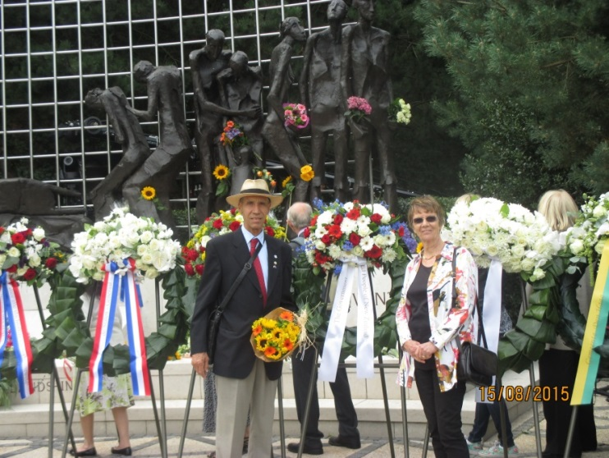
Ivo & Sophie Pabbruwe at the Indisch Monument, Den Haag.

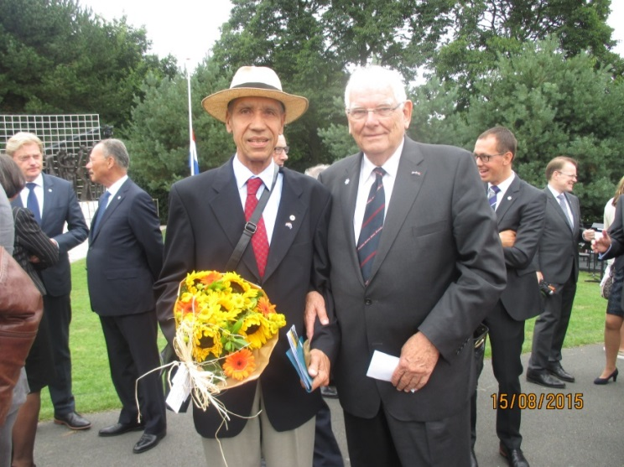
President EJOS Ivo & president SJE (JES) Jan van Wagtendonk.

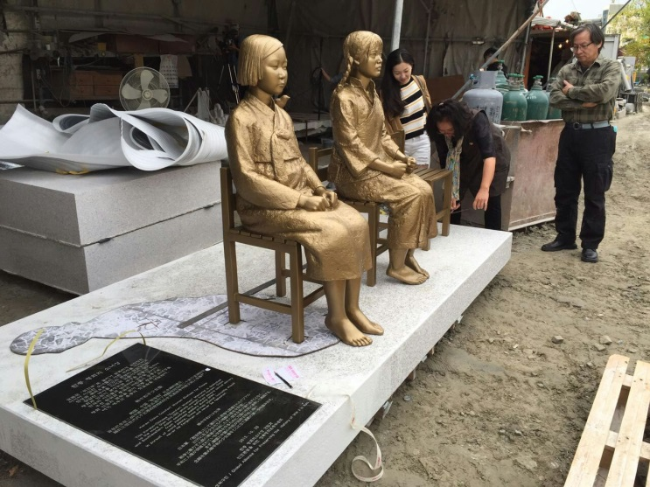
KOREA CHINA Comfort Women statues for PEACE. SEOUL, Korea.

Both girls wear the traditional clothing of their country. They look around 14 – about the same age as many comfort women when they were forced into military brothels run by Japan's imperial army. Unveiled at the end of October 2015.

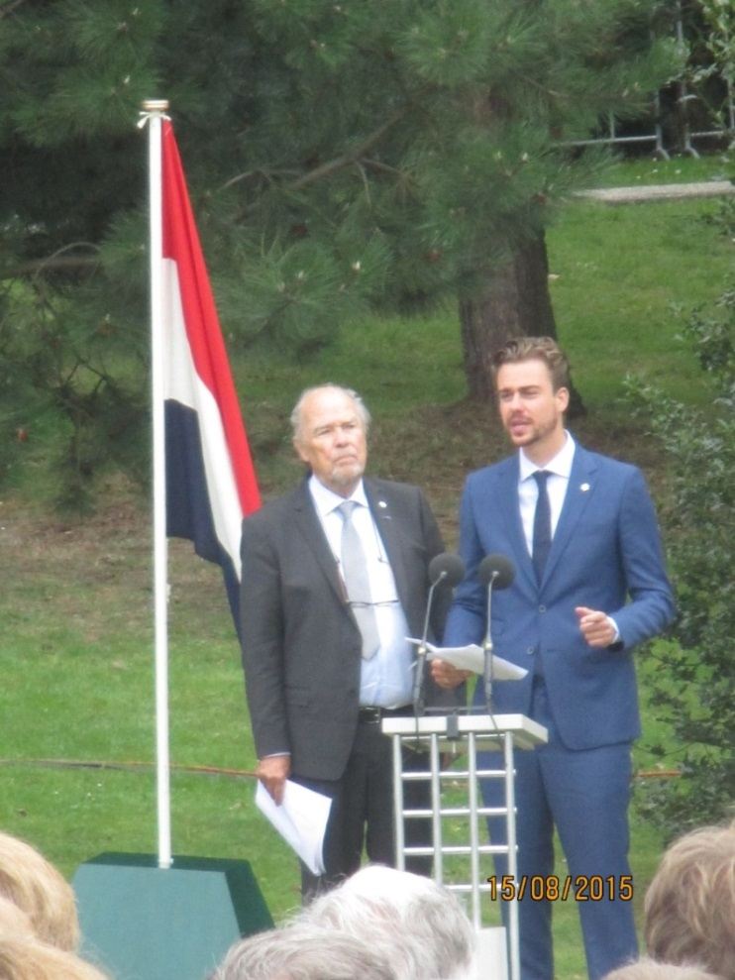
Actor Eric Schneider & son Beau with the authentic Ambarawa Dutch flag.

- Some information:
1945;President Truman warns Emperor Hirohito that he has something 10 times more powerful than the fire bombs on Tokyo. The bomb was actually 100 times more destructive.
The Japanese Military regime cabinet stopped the Japanese Emperor to capitulate. Consequently a 2-nd bomb was dropped on Japan. “Next is Tokyo”. and Hirohito capitulated.
75 % of the Japanese believe the A-bomb as a crime and commemorate this each year.

Did you know that 45 % of ex PoW’s from the Dutch-East-Indisch live overseas?
- “Leave No Survivors”
With the end of the war imminent the Kempeitai operated a “leave no survivors” policy and oversaw the notorious death marches of British and Australian PoWs. They were still beheading captured Allied pilots two weeks after the official surrender in August 1945. The Kempeitai destroyed all evidence to cover their tracks. Few were brought to trial.
14th August:In a special interview of one of the pilots of the B-29; “I never thought of people being down there”. One of my children married a Japanese and ironically I now have Japanese grand-children.And I do know that some EJOS members have Japanese connections like that.

- Herman Bussemaker
Indisch Platform chairman for many years Herman Bussemaker passed away 21 OCT 2015. Born in 1935 in Soerabaja where his parents had an orange plantation on East-Java.
He escaped incarceration in a Jap-Camp because his mother was Indisch-Dutch. His father perished as a PoW. In 1950 Bussemaker went to The Netherlands where he completed HBS-B and graduated in chemical engineering at the TU-Delft. The last years Bussemaker was a member of many Indië organisations. He wrote the first book about the Bersiap in the Dutch language. “Opstand in het Paradijs”, “Bersiap. Revolt in paradise” Despite the fact that he was ill, he was still able to publish a second book last year. 'Indisch grief and struggle for recognition'.
He has done a lot during his chairmanship of the Indisch Platform. I met him several times.

- SJE petition 251, 13 OCT 2015
Exellency, In your statement on the 70th anniversary of the end of World War II you admit “that Japan lost sight of the overall trends in the world.” Obviously you took that in consideration when you pledged at the annual UN meeting in New York $ 1.5 billion for the Middle East refugees and for peace building in the Middle East and Africa. In doing so you realize what sufferings victims of war conflicts have to endure.

- Statement by Fumio Kishida, Minister for Foreign Affairs of Japan
Statement at the United Nations General Assembly Meeting to Commemorate the International Day for Total Elimination of Nuclear Weapons, 30 September 2015, New York:
His Excellency, Mr. Mogens Lykketoft, President of the United Nations General Assembly, Distinguished delegates, Ladies and Gentlemen
I would like to express my profound appreciation to President Lykketoft and those who have worked hard to make this meeting possible.
Mr. President,
70 years ago, an atomic bomb was dropped in Hiroshima, my hometown, and Nagasaki and took more than two hundred thousand precious lives in a blink of an eye. In this milestone year of 70th year since the dropping of atomic bombs, Japan has renewed its commitment towards a world free of nuclear weapons.
Mr. President,
In order to advance nuclear disarmament, it is of the utmost importance that nuclear weapon states and non-nuclear weapon states cooperate and steadily build up tangible and practical measures.
Mr. President,
This year, after all the average age of atomic bomb survivors, Hibakushas, has become over 80. Hibakushas have strong feelings not to let the memories of their experiences fade away and to achieve the total elimination of nuclear weapons. I pledge with renewed determination to pass on strong feelings by Hibakushas across borders and generations and realize a world free of nuclear weapons.
Thank you very much for your attention.

- Corrie Beets, passed away last MAY 2015.
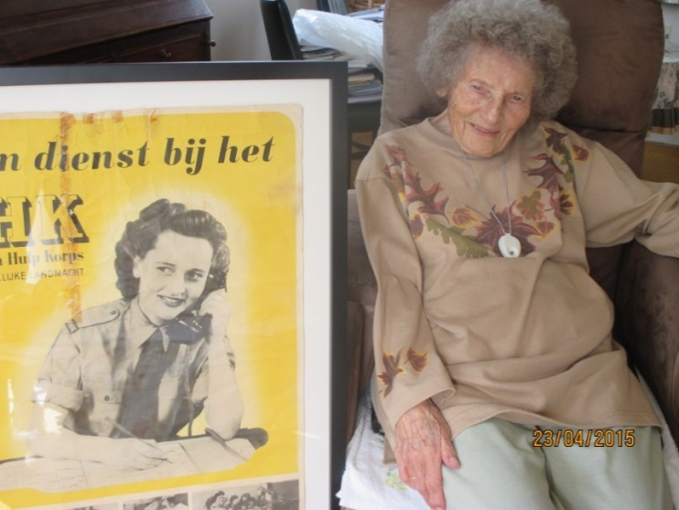
Corrie Beets when she was 21 in Den Haag and at 93 in HCK.
- TENKO: TV-series on the NET. Here the site: www.youtube.com/watch?v=2CmSsQWTWgw

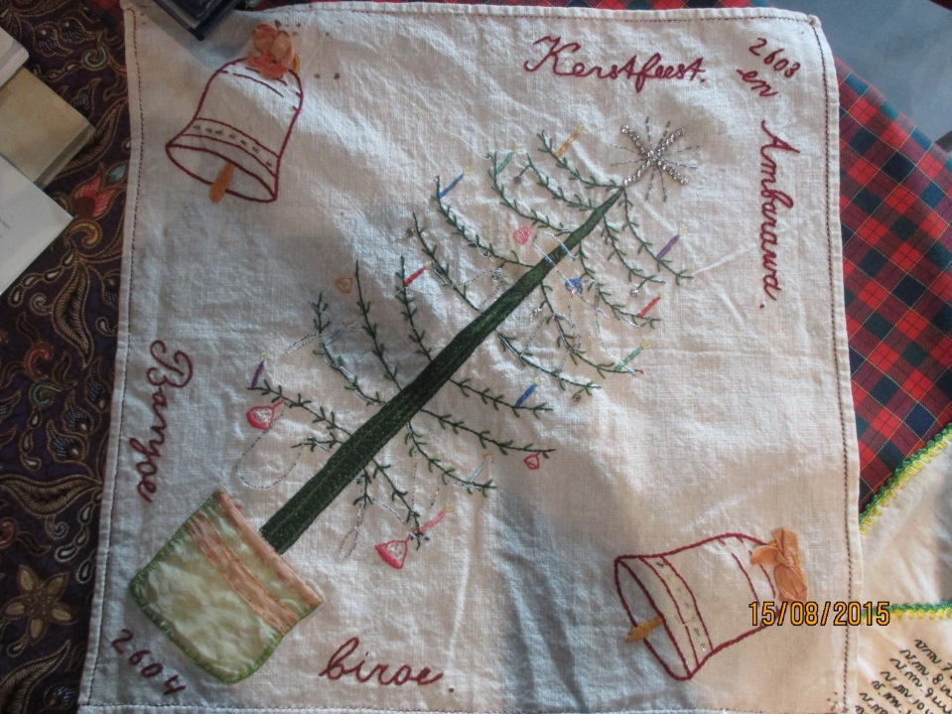
AMBARAWA/ BANJOE BIROE. Christmas Embroidery.
How about this beautiful embroidered serviette considering the
Circumstances in the Camp.

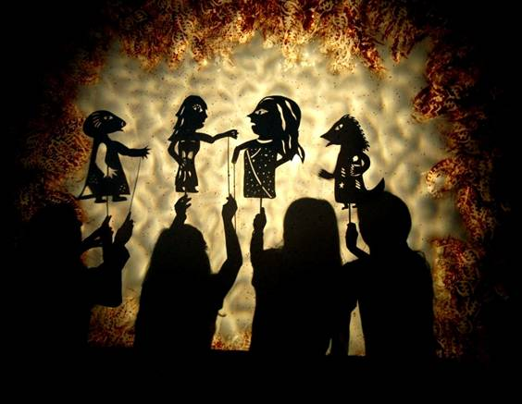
Wajang performance.

Latest news. Last 4-th of NOV Minister Martin van Rijn announced that all KNIL and bureaucrats, who are still alive, will get paid €25,000. The back-pay issue is hereby finalised.
They must have been officially in service until the 15-th of AUG 1945.
(Ze moeten tot 15 augustus 1945 formeel in dienst geweest zijn van het Nederlands-Indische gouvernement als ambtenaar of als militair( KNIL, Gouvernements Marine)
Indisch Platform chairman Silfraire Delhaye is trying to meet with SVW Martin van Rijn concerning the lost goods issue.

