Beste mensen,
Hier een verslag van de Global Alliance to preserve the history of WWll in the Pacific.
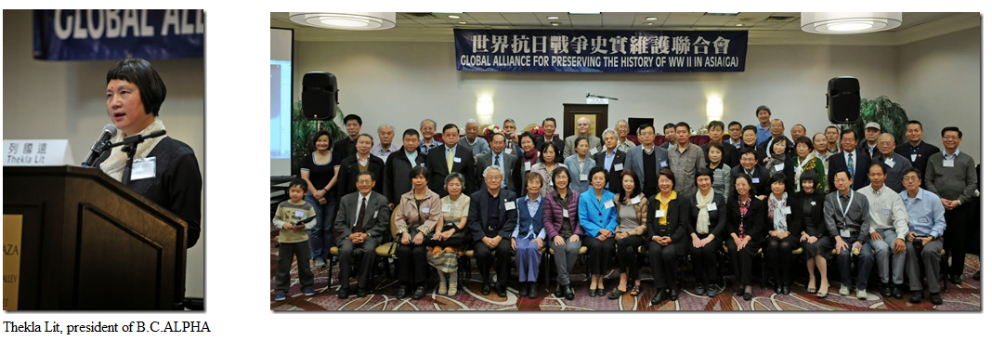

Zaterdag werd geopend door de organisator die verder niet meer aan bod kwam overigens.
Ik vermeld dit, omdat Jan van Wagtendonk had voorgesteld de SJE speech door hem te laten uitlezen.
Ik heb mijn speech voor gelezen en die werd goed en met interesse ontvangen.
Ik stelde als slot voor om in 2015 weer een advertentie in de krant te plaatsen.
Van Ignatius Ding vernam ik dat de advertentie in de New York Times van 2001 $80,000 kostte en dat was met een 50% korting.
Jullie begrijpen dat het plaatsen van een advertentie nu dus aan de dure kant wordt en waarschijnlijk niet verwezenlijkt zal kunnen worden.
Na mijn voordracht las ik de SJE speech voor van Jan van Wagtendonk, die ook weer goed werd ontvangen.
Dus ik kan terug kijken op een goed resultaat.
Er waren enkele vertegenwoordigers van de Toronto, Canada, Global Alliance aanwezig.
De lezers zijn allemaal gepensioneerd begreep ik en vaak professor of andere hoge functie gehad.
Soms werd de lezing onderbroken en soms ging het debat dan over in het Chinees. Ignatius was dan weer de vertaler. Heel goed en aardig van hem om mij over de toedracht/situatie in te lichten.

ALPHA presidente Thekla Lit vertelde in haar toespraak dat in haar woonplaats, Vancouver, een plan is een Museum te bouwen. Men is geld aan het verzamelen. Het Museum is in de vorm van de haven van Nanjing. Ziet er geweldig uit, maar zal nog even duren i.v.m. bouw kosten. ALPHA kennende zal het toch wel doorgaan denk ik.

De andere voordrachten kwamen ook allemaal terug op de Comfort Women, dat nog steeds hoog op de agenda's staat bij iedereen die daar aanwezig was. - En Japan blijft maar ontkennen omdat er geschreven documentatie over, is volgens hun -
Ontmoette Jenny Chang, die 6 ex Comfort women in China heeft geinterviewd.
Zij is een jonge vertegenwoordigster, die zich daar in verdiept. Heel goed om jong bloed er bij te hebben.

Ontmoette daar Ying Ying Chang, de Moeder van de zo jong overleden Iris Chang die de "Massacre van Nanjing" geschreven heeft. Iris was bezig met een onderzoek van de "Bataan doden mars" in de Philipijnen voor een boek.
Dat boek is dus niet afgemaakt, helaas. Ze had zich er zo in verdiept dat ze het niet meer zag zitten en jammer genoeg zelfmoord heeft gepleegd.

Lunch en avond eten was goed, maar ik had helaas de hint van Jose om een vork en lepel mee te nemen in de wind geslagen. 90% Van de conferentie waren (Taiwanees) Chinees dus was het wel even zoeken naar bestek voor mij.
Vis en schelpdieren, garnalen, kreeft en krab, waren standaard op het menu. Er werd veel geslurpt, kan niet veel anders met die chop-sticks, en veel thee gedronken. (en ik drink geen thee!)
Ik vroeg naar koffie en de ober zei dat ik dat bij Star Bucks moest halen een eindje verderop.
Moest dus mee wachten tot op mijn Hotel kamer, waar ik een koffie machine had.

Vriendelijke groeten van Ivo.
________________________________

Speech van de voorzitter van de Stichting Japanse Ereschulden, dhr. J.F. van Wagtendonk, voorgelezen door Ivo

Dear Thekla and Ivo,
Due to family circumstances regrettably I will not be able to attend the Global Alliance conference on November 14.
I am grateful that Ivo is prepared to present my paper on War crimes by the Japanese military in Dutch East Indies. It is a short paper based on Mr. De Groot’s first-hand experience as observed in his book on the subject.
I did not attempt to describe neither the horrendous methods of interrogations and torture nor the methods in which the Japanese administrators starved, subjected to discipline and denied medicine to the Dutch prisoners in the concentration camps and terrorized the Dutch left outside the camps.
The facts are that the Japanese military violated the laws and customs of war and ignored on a grand scale the internationally accepted conventions, to which Japan did describe to prior to the Pacific War. These facts were established in professional Courts of Law and as such recognized in the 1951 San Francisco Peace Treaty.
I call on Japan and its present government to acknowledge these facts, be ashamed and offer genuine excuses and a solatium to the victims.
In the attached petition 240 I call on the Prime Minister of Japan, as a result of the state visit by the Dutch King to Japan, to take up the challenge set by both the Emperor of Japan and the King of the Netherlands.
I presume that the paper and the attached petition are going to be distributed to the attendees.
Ivo, thank you for offering to present the paper. I am sure you will be able to impress them with your own paper and that my paper will back pedal on it.
Good luck and enjoin your trip into the heartland of Silicon Valley.
Best regards,
Jan van Wagtendonk
_____________________________________

Ivo Pabbruwe, EJOS Inc, NEW ZEALAND. NOV 2014.
Let me introduce myself. I was born the former DEI in 1940. In 1942 the Japanese Imperial Army invaded the DEI, which capitulated in March. “Asia for the Asians” was the Japanese Army’s motto and the Dutch colonists were pushed aside and eventually taken prisoner and incarcerated in Camps. I survived the Japanese internment, together with my baby brother, thanks to my Mother. I represent the Ex Japanese PoW’s in the former DEI living in New Zealand. The deadly atomic bomb was our saviour in AUG 1945 for many women, men and soldiers. Including Japanese in Japan, because they were told and be ready to fight until death in case of an Allied invasion.
On the 28th of JUL 2014 the last surviving crew member on the “Enola Gray” B-29 Superfortress bomber, which dropped an atomic bomb on Hiroshima on 6-th of AUG 1945, passed away at the age of 93 of natural causes. That was Theodore van Kirk, also known as “Dutch”. He was 24 at the time. In a 2005 interview with the AP, van Kirk said his World War II experience showed that wars and atomic bombs don’t settle anything and he’d like to see the weapons abolished. Van Kirk felt the bombing of Hiroshima was worth the price in that it ended the war before the invasion of Japan, which promised to be devastating to both sides. “I honestly believe the use of the atomic bomb saved lives in the long run. There were lots of lives saved. Most of the lives saved were Japanese.” “I pray that no man will have to witness that sight again. Such terrible waste, such a loss of life. We unleashed the first atomic bomb, and I hope there will never be another. I pray that we have learned a lesson for all time. But I’m not sure that we have.”
Emperor Hirohito at the time of the surrender in 1945 ordered the Japanese Government to prepare a text accepting surrender, because peace was preferable to destruction.
The Emperor Akihito was never advised about his father’s attempt to admit his war shame. His father Emperor Hirohito was to express “DEEP SHAME at his IMMORALITY” according to a newly discovered document.
Later on the Japanese Government passed a motion expressing “deep remorse” for the war, which subsequent prime ministers have echoed.

TIME Magazine June 2, 2014
Letters: In your latest Time 100 issue, you once again celebrate the merits of Shinzo Abe, this time through the economic lens of a former U.S. Treasury Secretary. No doubt Abenomics may have helped his nation overcome the last crisis, but the other aspects if his political attitude fearfully reminds us of relentless Japanese mishandling of history: “Japan über alles” regardless of due repentance that Japan should show to its Asian neighbors. Christophe Nicolas, St.-RÉMY LÈS Chevreuse, France.

In Europe we may have focused too much on the Nazi concentration camps to the exclusion of the Japanese ones. In some ways they were worse. But who can tell?
Lady Louis Mountbatten, who has travelled over 100.000mls, visited all the camps including those in Hong Kong, Indo China & the former Dutch-East-Indies. Of the Dutch women internees in Java Lady Louis said; “I have unbound admiration for their courage. Their camps were the worst of all PoW camps and the way these women kept going was astounding.
On December 6, 1991, 3 Korean women filed charges against the Japanese government. Of the three plaintiffs, only one was willing to name herself: Kim Hak-soon (sometimes referenced as Kim Hak-Sun). On April 13, 1992, 6 more Korean women filed suit, among them a woman named Shim Mi-Ja.
In 1992 after their revelation and publication a Dutch lady, Jan Ruff O’Herne, joined them and a meeting was arranged. She had been silent that she was a CW for 50yrs. One of the worst things that happened was that one day twenty girls in the age of 14 till 20 were "chosen" to serve as comfort girls. Jan Ruff-O’Herne was the first European woman to break her silence. She first told her daughters in 1992 and then gave testimony in Tokyo about suffering brutal serial rape in the House of the Seven Seas in Java. I will get back to Jan later on.
I do not think that even today, the Japanese government, unlike German government, fully accepts the responsibility of their war time crime. The matter is still generating much tension between China, Korea and Japan.
CW. Last April the ALPHA Canada organization promoted the Chinese Comfort Women book at the Vancouver Public Library and Richmond Public Library to host these author talks with Prof. PeiPei Qiu. The book publishes Testimonies from Imperial Japan’s Sex Slaves. It is the first English account of the unfathomable atrocities experienced by Chinese women who were forced to become ‘comfort women’ during Japan’s invasion of China.
In March I received a letter from the Dutch ex CW Jan Ruff O’Herne. She writes;
The “Melbourne Age” newspaper wrote a long article about the hideous denial of Japanese PM Mr Abe, that the “Comfort Women” existed at all. In response to that article I had a visit of 4 Korean gentlemen who wanted to interview me. They had a camera man also who filmed the interview and this will be on TV and Newspapers all over the world. So, we see again, the story never stops. I am still alive, while Mr Abe is waiting for all the CW to be dead, so that there can be no more testimonies. Most Korean CW have died. The 4 Korean men are from Sydney. One of them is an artist and a sculptor, who is making a sculpture of 3 Comfort Women together. One from Korea, one from China and then myself from Indonesia. It will be placed somewhere in Sydney and should be ready by August 15. I want to thank you, dear Ivo, for all the interest you are showing and support for the CW. I am still going strong at 91. I have 2 lovely great-grandchildren, who are a great joy to me.
SEOUL, 26 APR 2014-- Using surprisingly harsh language to condemn Japan's wartime brothels, U.S. President Barack Obama on Friday urged Tokyo to squarely face its past and work toward improving relations with Seoul

APR 2014. Japan is opposing plans for a statue in Sydney honouring up to 200,000 women forced to work as sex slaves for Japanese soldiers during WWII.
The latest denial was from Chief Cabinet Secretary Yoshihide Suga saying recently that no evidence can be found to prove the comfort women were "forcibly recruited". However, for Felicidad De los Reyes, an 86-year-old Filipino, a victim of such sexual slavery, Suga's remarks are ridiculous since she herself is a living testimony to refute the Japanese top government spokesman. Reyes was still a school girl in 1943 and was enrolled in a program to welcome Japanese soldiers in her school where a garrison of the Japan's Imperial Army was based. Reyes, who was only 14 at that time, said the Japanese took her to temporary buildings for women who do chores for the Japanese troops in the back of the school and she was pushed into a room where she suffered the worst nightmare of her life.
A symbolic gesture.
Campaigners hope to commission a life-size bronze sculpture featuring three women standing together, with hands clasped.
Jan Ruff O’Herne’s daughter Carol Ruff says the statue would have meaning far beyond the local Chinese and Korean community. "I was just speaking to my mother about this. She pointed out that in our country and in our cities we have so many monuments to men who have suffered and fought in war. And we don't really have much for women who have fought in war, and we certainly do not have any statues or monuments to remember women who have been raped in war. And I think therefore that to put something like this is Strathfield is really progressive and really pertinent. And it would mean a lot to a lot of members of the community not just to to members of the people who are connected directly to Japan or Korea. I think it has a broader reach."
The story started when a Korean and Chinese alliance group suggested a bronze $100,000 statue by Chinese artist Jian Hua Qian be placed on the town square.
The "Three Sisters" was to commemorate the 200,000 women used as sex slaves by the Japanese army during World War II. The Chinese and Korean communities have agreed to pay for it to be cast in bronze, and for its upkeep. "comfort women" issue is highly sensitive and controversial among the Japanese, Koreans and Chinese.
Japan's Prime Minister provoked outrage when he suggested the comfort women may have willingly provided sexual services to Japanese servicemen.
Spokesman Hiroshi Nawata says Prime Minister Abe is "deeply pained" to think of what he calls the "immeasurable pain and suffering" the comfort women experienced. However he says that the proposed statue is not compatible with Japan's position.
'Comfort women' deserve a memorial: their ordeal must not be forgotten
My mother was forced into sexual slavery by the Japanese military. To hear the Japanese prime minister say 'comfort women' were voluntary prostitutes is shocking.

Japanese opposition to 'comfort women' statue in Sydney

While Shinzo Abe recently committed to letting a 1993 apology to the women stand, the Deputy Mayor of Strathfield, Sydney, Sang Ok, says Japan is trying to revise history. He says Japan's position on wartime atrocities stands in stark contrast with that of Germany. "They (Germany) are repeatedly apologising, repeatedly trying to compensate or to help those war victims. But in contrast to Germany what does Japan do? What the current Japanese government is doing is totally different. They want to conceal, deny the war crimes."[ They have been doing so ever since the San Francisco treaty in 1951!] The Japanese government said most recently that it may reconsider the study and the apology -However, Prime Minister Abe clarified on 14 March 2014 that he had no intention of renouncing or altering it. What does that mean?

UN requests Japan to redress 'comfort women' issue

(Xinhua)Updated: 2014-07-25. GENEVA - The United Nations Human Rights Committee raised its concerns over the issue of "comfort women" and requested Japan to make immediate and effective efforts to redress this issue. The UN committee made the request in its concluding observations on the sixth periodic report of Japan on its implementation of the International Covenant on Civil and Political Rights (ICCPR).
In OCT I received correspondence from Jan Ruff O’Herne; In reply I enclose the speech my daughter Carol made at the opening of the CW statue, erected in Strathfield. Carol lives in Sydney. I think that the enclosed letter answers your question. I hope you are well. I am still going strong at 91. All my best wishes and thanks for all the work you are doing. Love, Janny.
Daughter Carol; My mother was a Dutch colonial girl born on Java in the Dutch-East-Indies. She was interned in prison camp. In 1944, when she was just 21yrs old, she was taken away from the camp and forced into sexual slavery by the Japanese military. She was repeatedly raped and beaten for a period of 3 months, along with other Dutch girls. She was then returned to the prison camp with threats that her family would be killed if she revealed the truth about the atrocities inflicted upon her. For 50yrs she told no one of her war-time experiences. In 1992 when she saw the Korean war raped victims making appeals for justice on TV, she finally spoke out. She did this at an International Peace Tribunal in Tokyo. She spent 15yrs working tirelessly to protect the rights of women in war and armed conflict. Her testimony was instrumental in rape being declared a war crime by the United Nations. In Tokyo Jan was approached by a group of concerned ex Japanese military men who said they were just obeying orders when they used the Comfort stations. I spoke to my mother recently and she pointed out that we have a number of monuments and bridges for former soldiers, but women are often the forgotten heroes of war. The pain and humiliation of sexual servitude is great. They did not go voluntary into those terrible places. Their young lives were ruined forever. The proposed statue would be a milestone artwork in Australia and very progressive for the Strathfield council to erect such a monument. This is not a vindictive act towards the Japanese people. It is a gesture towards reconciliation and healing of the wounds of World war ll. Only through truth can we move forward and learn from the past.

On Oct. 1, Prime Minister Shinzo Abe said he had no intention “right now” of revising the statement or issuing a new one. But he was later contradicted by a close adviser, LDP lawmaker Koichi Hagiuda, who said: “We do not intend to review the Kono statement as it has already finished its role,” adding that a new proclamation to be issued next year would “emasculate” the Kono statement.
Mr. Abe, though, is unlikely to publicly deviate from his current stance while he angles for meetings with his South Korean and Chinese counterparts at the upcoming Asia-Pacific Economic Cooperation summit in Beijing.
Commemoration End of WWll.
5 MAY 2014 was the commemoration of the Liberation Day in the Netherlands. Prime minister Mark Rutte & VWS minister Martin van Rijn laid a wreath at the National monument for the Dutch-East-Indisch. AUG 15 Special commemorations were held in several places in the Netherlands, Los Angeles and I organized one followed by a typical Indonesian Lunch in New Zealand.
MONUMENTS.
15 JUL 2014. Fairfax, Virginia – A simple granite boulder flanked by two turquoise butterfly benches has been silently sitting on the grounds of Fairfax County’s government office.
The butterflies are a symbol for the Comfort Women and “signify hope and freedom from discrimination.” The butterfly has long been a Christian symbol of resurrection, for it disappears into a cocoon and appears dead, but emerges later far more beautiful and powerful than before. The plaque on the memorial reads: “May these ‘Comfort Women’ find eternal peace and justice for the crimes committed against them. The Comfort Women’s countries of origin are “Korea, China, Taiwan, the Philippines, Indonesia, Malaysia, Vietnam, the Netherlands and East Timor.”

Coastwatchers FROM 1941 until the cessation of hostilities, New Zealand coastwatchers maintained a lonely vigil on islands scattered over sixteen million square miles of the Pacific Ocean, engaged in the most monotonous and unspectacular of all war service.
On 7 October 2014 Coastwatchers executed by the Japanese during World War II have been remembered in New Zealand with the unveiling of a memorial on Wellington's waterfront. Coastwatchers were Allied military intelligence stationed on remote Pacific islands during World War II to observe enemy movements and rescue stranded Allied personnel. On 15 October 1942, 17 New Zealanders - 10 soldiers and seven Post and Telegraph radio operators - were rounded up by the Japanese in the Northern Gilbert Islands, now known as Kiribati, and killed. One was killed after he escaped and the remaining 16 were beheaded. Six other civilians were also executed. Survivor Mr Jones, who was also captured and spent time as a prisoner of war in Japan, lobbied for years for a memorial and refused to attend Anzac Day ceremonies. He believed successive governments kept quiet about the killings so as not to make trouble with post-war Japan, he told Fairfax.
THE CHRISTIAN SCIENCE MONITOR, By Justin McCurry, Correspondent October 27,2014. PM Abe sees opening to replace Japan's 'comfort women' apology.
Conservative Japanese commentators and politicians, including Prime Minister Shinzo Abe, seized on Asahi’s mea culpa in an attempt to challenge the version of events implicit in the Kono statement. Their push has raised fears that the apology will be ditched, possibly to mark the 70th anniversary of the end of the war next year.
Senior figures in the ruling Liberal Democratic Party (LDP) now hope to replace Mr. Kono’s landmark apology with a new version that restores “the honor of those in the past who were inappropriately demeaned and to protect the pride of the Japanese living in the present and future,” according to a statement.

An OPEN PETITION TO THE TENNO HEIKA. 70 YEARS AFTER JAPAN’S SURRENDER.
Years and years, for 70 years Japan still claims their war atrocities a myth, since the Supreme Commander of the Allied Forces, General Dwight Eisenhower ordered to get the films and witnesses of these atrocities – because somewhere down the road somebody will get up and say that this never happened. And NOW 70 years later, more than ever, it’s imperative to make sure the world never forgets. WHO IS THIS VILLAIN that gets up to deny it’s past? The films still exist; the German diaries still exist.

On the 5-th of SEP 2001 the NEW YORK TIMES published a full page advertisement.
SHOW THE PAPER
GERMANY HAS FACED ITS CRIMES AGAINST HUMANITY. WHY NOT JAPAN On SEP 8, 1951, the San Francisco Peace Treaty blocked restitution for millions of Japan’s victims in the Asia-Pacific War; Today the survivors still have no redress. With your help, that will change.
In August 2014 the world marked the 100th anniversary of the outbreak of the First World War. Also the theme at the Chelsea Flower Show in England
Next year, 2015, the Japanese surrender will be 70 yrs ago and we are still fighting for justice.
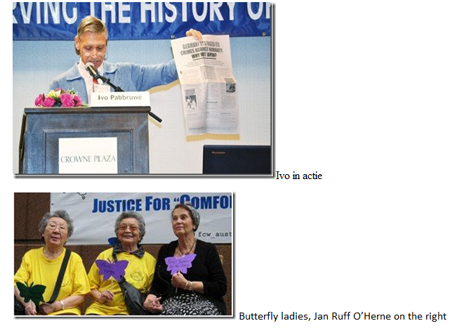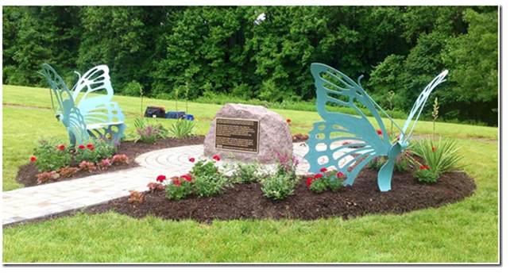
5 JUL 2014. Fairfax, Virginia – A simple granite boulder flanked by two turquoise butterfly benches has been silently sitting on the grounds of Fairfax County’s government office.

